Even Numbers
# Source: AI Source: Provided by: [Data Path: Persons Table -> ID Column: 1, Name_En Column: Motasem Essam] -> From: [ChatGPT] on [7/13/2026]
Even numbers are integers that are exactly divisible by 2, leaving a remainder of 0. They form one of the two classes of integers under parity, the other being odd numbers.
Even numbers are fundamental in arithmetic, elementary number theory, algebra, computer science, and many areas of mathematics.

Definition
# Source: AI Source: Provided by: [Data Path: Persons Table -> ID Column: 1, Name_En Column: Motasem Essam] -> From: [ChatGPT] on [7/13/2026]
An even number is an integer that is divisible by
$$2.$$
Mathematically, an integer
$$n$$
is even if there exists an integer
$$k$$
such that
$$n=2k$$
where:
- $n$is the given integer.
- $k$is an integer.
Equivalently,
$$n≡0(mod2).$$

Rules for Even Numbers

1. An Even Number Is Divisible by Two
# Source: AI Source: Provided by: [Data Path: Persons Table -> ID Column: 1, Name_En Column: Motasem Essam] -> From: [ChatGPT] on [7/13/2026]
Every even number can be divided by
$$2$$
without leaving a remainder.
Example
$$24÷2=12$$

2. An Even Number Has the Form $2k$
# Source: AI Source: Provided by: [Data Path: Persons Table -> ID Column: 1, Name_En Column: Motasem Essam] -> From: [ChatGPT] on [7/13/2026]
Every even integer can be written as
$$2k$$
for some integer
$$k.$$
Example
$$-14=2×(-7).$$

3. Zero Is an Even Number
# Source: AI Source: Provided by: [Data Path: Persons Table -> ID Column: 1, Name_En Column: Motasem Essam] -> From: [ChatGPT] on [7/13/2026]
Since
$$0=2×0,$$
zero is even.
Example
$$0$$
is an even integer.

4. Negative Integers Can Be Even
# Source: AI Source: Provided by: [Data Path: Persons Table -> ID Column: 1, Name_En Column: Motasem Essam] -> From: [ChatGPT] on [7/13/2026]
Parity applies to all integers, including negative numbers.
Example
$$-20=2×(-10).$$
Therefore,
$$-20$$
is even.

5. Consecutive Even Numbers Differ by Two
# Source: AI Source: Provided by: [Data Path: Persons Table -> ID Column: 1, Name_En Column: Motasem Essam] -> From: [ChatGPT] on [7/13/2026]
The difference between consecutive even numbers is always
$$2.$$
Example
$$8, 10, 12, 14.$$

6. Every Even Number Greater Than Two Is Composite
# Source: AI Source: Provided by: [Data Path: Persons Table -> ID Column: 1, Name_En Column: Motasem Essam] -> From: [ChatGPT] on [7/13/2026]
Every even integer greater than
$$2$$
is divisible by
$$2,$$
so it has more than two positive factors.
Example
$$18$$
is divisible by
$$2$$
and
$$9,$$
so it is composite.

7. The Only Even Prime Number Is Two
# Source: AI Source: Provided by: [Data Path: Persons Table -> ID Column: 1, Name_En Column: Motasem Essam] -> From: [ChatGPT] on [7/13/2026]
Among all even numbers, only
$$2$$
has exactly two positive factors.
Example
$$2$$
is both even and prime.

Examples
# Source: AI Source: Provided by: [Data Path: Persons Table -> ID Column: 1, Name_En Column: Motasem Essam] -> From: [ChatGPT] on [7/13/2026]
Example 1
Determine whether
$$16$$
is even.
Since
$$16=2×8,$$
it is even.

Example 2
Determine whether
$$0$$
is even.
Since
$$0=2×0,$$
it is even.

Example 3
Determine whether
$$-8$$
is even.
Since
$$-8=2×(-4),$$
it is even.

Example 4
Determine whether
$$51$$
is even.
Since
$$51$$
is not divisible by
$$2,$$
it is not even.

Example 5
List the even numbers between
$$10$$
and
$$20. \\ 10, 12, 14, 16, 18, 20.$$

Example 6
Determine whether
$$102$$
is even.
Since
$$102÷2=51,$$
it is even.

Properties of Even Numbers
# Source: AI Source: Provided by: [Data Path: Persons Table -> ID Column: 1, Name_En Column: Motasem Essam] -> From: [ChatGPT] on [7/13/2026]
- Divisible by
$$2.$$
- Have the form
$$2k.$$
- Leave a remainder of
$$0$$
when divided by
$$2.$$
- May be positive, negative, or zero.
- Consecutive even numbers differ by
$$2.$$

Arithmetic Properties of Even Numbers
# Source: AI Source: Provided by: [Data Path: Persons Table -> ID Column: 1, Name_En Column: Motasem Essam] -> From: [ChatGPT] on [7/13/2026]
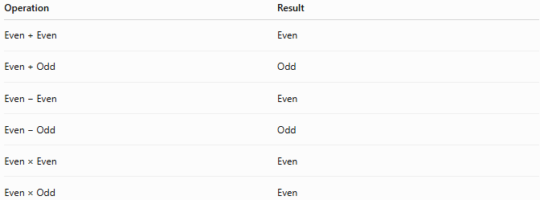
Operation | Result
Even + Even | Even
Even + Odd | Odd
Even − Even | Even
Even − Odd | Odd
Even × Even | Even
Even × Odd | Even

Real-Life Applications
# Source: AI Source: Provided by: [Data Path: Persons Table -> ID Column: 1, Name_En Column: Motasem Essam] -> From: [ChatGPT] on [7/13/2026]
Even numbers are used in:
- Computer science
- Digital communication
- Cryptography
- Engineering
- Algorithm design
- Mathematics education
- Data organization
- Manufacturing
- Scheduling
- Number theory

Real-Life Examples
# Source: AI Source: Provided by: [Data Path: Persons Table -> ID Column: 1, Name_En Column: Motasem Essam] -> From: [ChatGPT] on [7/13/2026]
1. Pairing Objects
Two shoes form one pair. A collection with an even number of shoes can be completely paired.

2. Seating Arrangements
An even number of students can be divided into two equal groups without anyone left over.

3. Computer Memory
Parity checking often relies on counting whether the number of binary
$$1$$
bits is even.

4. Packaging
A factory packing
$$24$$
items into pairs creates
$$12$$
pairs.

5. Sports Teams
A tournament with an even number of players can schedule matches with no participant left without an opponent in each round.

6. Programming
Programs frequently check whether an integer is even before applying specific algorithms.

Common Mistakes
# Source: AI Source: Provided by: [Data Path: Persons Table -> ID Column: 1, Name_En Column: Motasem Essam] -> From: [ChatGPT] on [7/13/2026]
- Thinking that zero is odd.
- Forgetting that negative integers can be even.
- Assuming every even number is composite.
- Forgetting that
$$2$$
is both even and prime.
- Confusing even numbers with multiples of numbers other than
$$2.$$

Key Points
# Source: AI Source: Provided by: [Data Path: Persons Table -> ID Column: 1, Name_En Column: Motasem Essam] -> From: [ChatGPT] on [7/13/2026]
- An even number is divisible by
$$2.$$
- Every even integer has the form
$$2k.$$
- Zero is even.
- The only even prime number is
$$2.$$
- Every even number greater than
$$2$$
is composite.
- Consecutive even numbers differ by
$$2.$$

Even Numbers vs. Odd Numbers
# Source: AI Source: Provided by: [Data Path: Persons Table -> ID Column: 1, Name_En Column: Motasem Essam] -> From: [ChatGPT] on [7/13/2026]
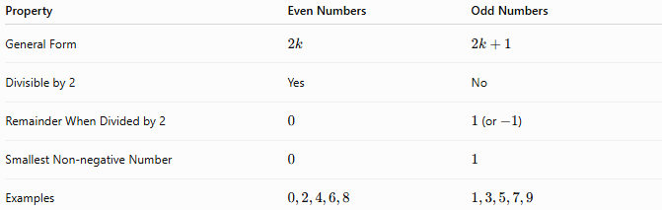
Property | Even Numbers | Odd Numbers
General Form | $$2k$$ | $$2k+1$$
Divisible by 2 | Yes | No
Remainder When Divided by 2 | $$0$$ | $1$(or $-1$)
Smallest Non-negative Number | $$0$$ | $$1$$
Examples | $$0,2,4,6,8$$ | $$1,3,5,7,9$$

Conclusion
# Source: AI Source: Provided by: [Data Path: Persons Table -> ID Column: 1, Name_En Column: Motasem Essam] -> From: [ChatGPT] on [7/13/2026]
Even numbers are integers that are divisible by 2, meaning they can be written in the form $2k$for some integer $k$. They include positive integers, negative integers, and zero. Even numbers are one of the two fundamental parity classes of integers and play a central role in arithmetic, elementary number theory, algebra, computer science, engineering, and many real-world applications involving grouping, divisibility, and computation.

